Anthony Rusignuolo

CS 600WS – Advanced Algorithms

Reza Peyrovian

Homework 11

I pledge my honor that I have abided by the Stevens Honor System.

1. R-21.5 What is the worst-case depth of a k-d tree deﬁned on n points in the plane? What about in higher dimensions?
   1. The depth or height of the tree is O(logn).
2. C-21.5 Design a static data structure (which does not support insertions and deletions) that stores a two-dimensional set S of n points and can answer, in O(log2n) time, queries of the form countAllInRange(a, b, c, d), which return the number of points in S with x-coordinates in the range [a, b] and y-coordinates in the range [c, d]. What is the space used by this structure?
   1. A two-dimensional range tree with an input of an immutable set S of points can be searched and counted in O(log2n) using algorithm 21.2, but instead returning a count as opposed to the s items in the range specified.
3. A-21.3 In some applications, such as in computer vision, an input set of two-dimensional points can be assumed to be given as pairs of integers, rather than arbitrary real numbers. Suppose, then, that you are given a set of n two-dimensional points such that each coordinate is in the range [0,4n]. Show that you can construct a priority search tree for this set of points in O(n) time.
   1. Algorithm 21.4, but with radix sort instead of heap or merge sort.
4. R-22.8 Draw as best you can the convex hull of the following set of points:  
   {(2,2),(4,4),(6,4),(8,1),(8,7),(9,3),(1,5), (5,4)}.
   1. 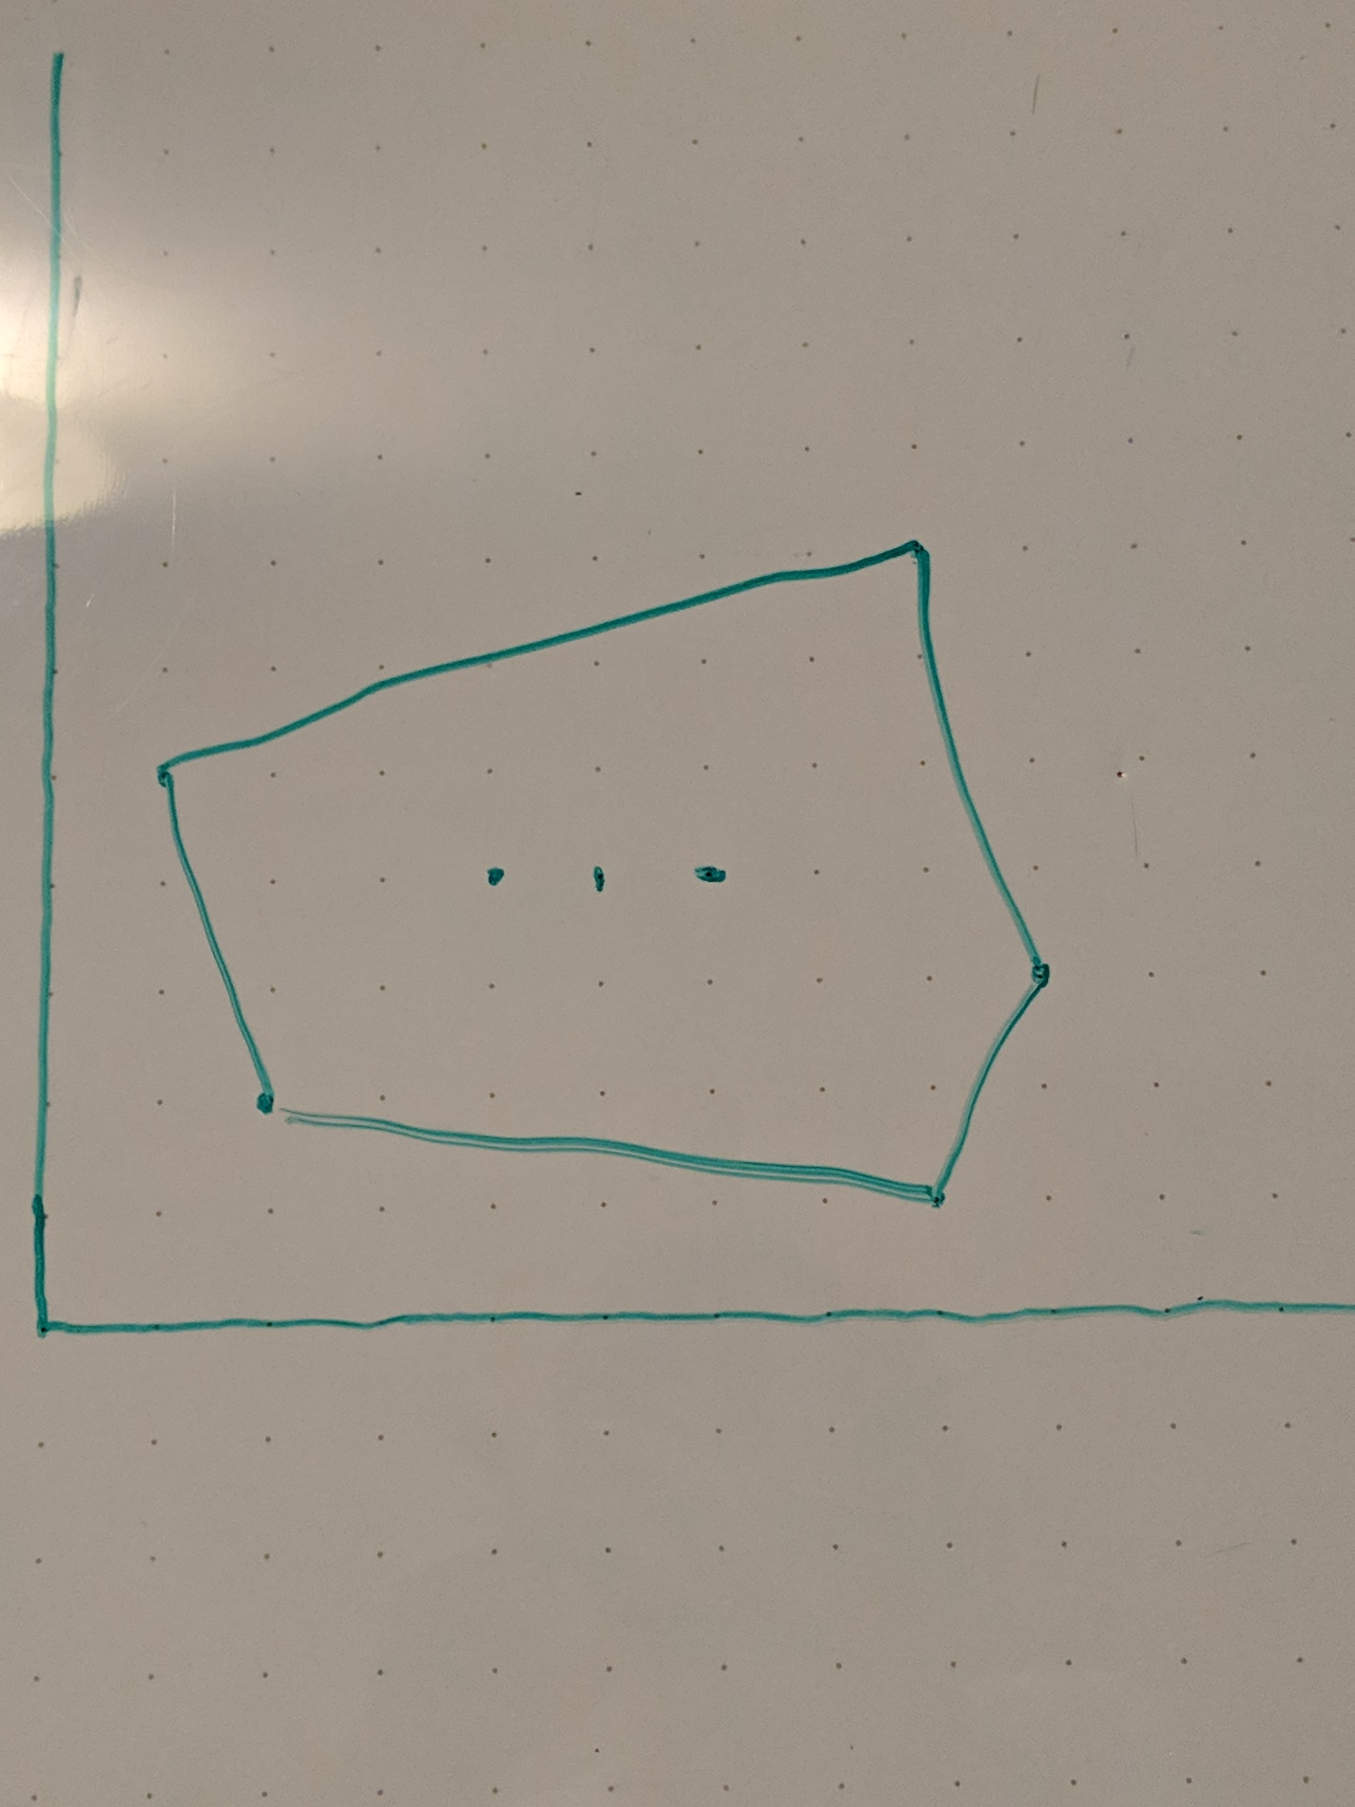
5. C-22.5 Design an O(n)-time algorithm to test whether a given n-vertex polygon is convex. You should not assume that P is simple.
   1. Use the gift wrapping algorithm.
6. A-22.2 Gerrymandering is a process where voting districts are drawn to achieve various political goals, such as maximizing the number of voters from a certain party, rather than to achieve geometric goals, such as having districts drawn to have generally round or square shapes. This process often gives rise to very complicated shapes for voting districts, and it can sometimes be challenging to deter-mine whether a giving person is inside or outside a given district, due to the ways it can wind around. Suppose, then, that you are given a voting district deﬁned by an n-vertex simple polygon, P. Give an O(n)-time algorithm for testing whether a point q is inside or outside of P. You may assume that q is not on the boundary of P and that there is no vertex of P with the same x-coordinate as q.
   1. Iterate through the vertices creating triangles and testing whether q is one any of those triangles. If so, return true. Else, return false.